Project Design Phase-II
Technology Stack (Architecture & Stack)

Date | 5/04/2026
Team ID
Project Name | Automating Data Import and Relationship Mapping Using Import Sets & Dot Walking
Maximum Marks | 4 Marks

Technical Architecture:
The Deliverable shall include the architectural diagram as below and the information as per the table1 & table 2
Example:
Automating Data Import and Relationship Mapping Using Import Sets & Dot Walking 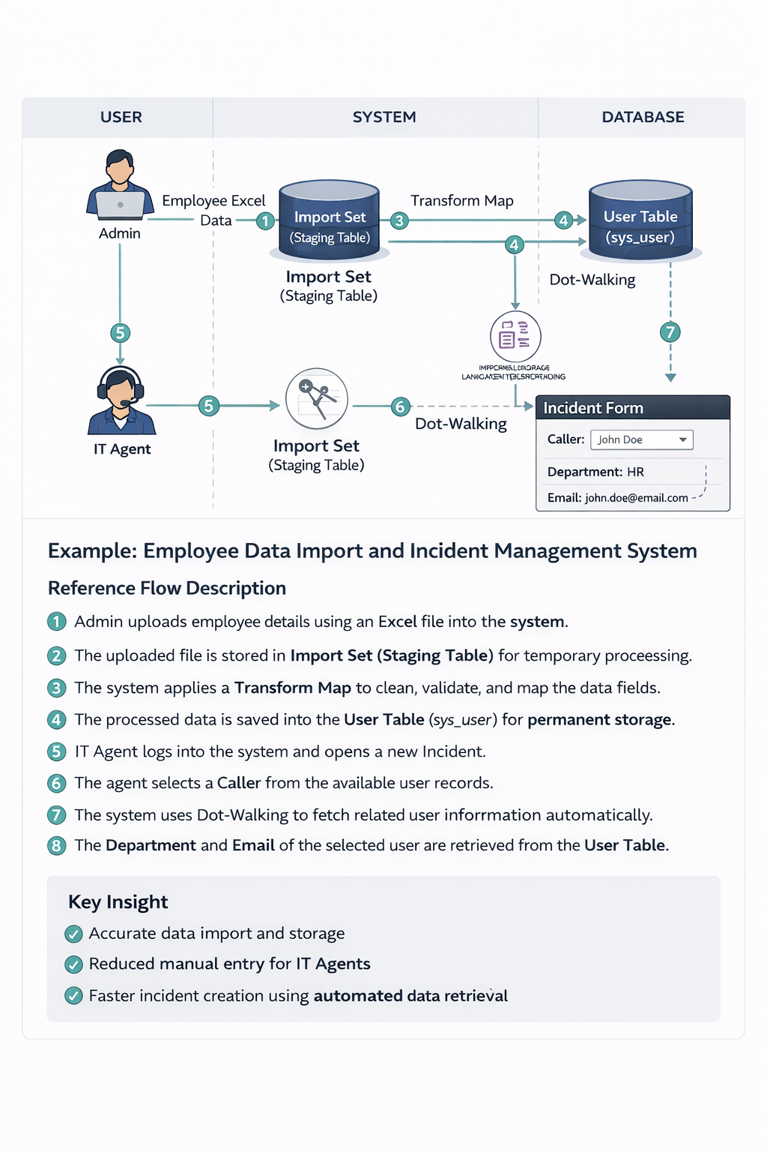

Table-1 : Components & Technologies:
S.No | Component | Description | Technology
 | User Interface | How the IT Agent and Admin interact with the system | ServiceNow Standard UI / Now Platform
 | Application Logic-1 | Staging external data before database entry | ServiceNow Import Sets
 | Application Logic-2 | Mapping data from staging to the target table | ServiceNow Transform Maps
 | Application Logic-3 | Fetching related record data automatically | ServiceNow Dot-Walking
 | Database | Target tables where the final data lives | Relational Database.
 | Cloud Database | Database Service on Cloud | IBM DB2, IBM Cloudant etc.
 | File Storage | Infrastructure | Application deployment and hosting | ServiceNow Enterprise Cloud
 | External API-1 | Purpose of External API used in the application | Not Applicable (Data is imported via static Excel files rather than a live API connection).
 | External API-2 | Purpose of External API used in the application | Not Applicable
 | Machine Learning Model | Purpose of Machine Learning Model | Not Applicable (This project utilizes deterministic relational mapping rather than predictive modeling).

Table-2: Application Characteristics:
S.No | Characteristics | Description | Technology
 | Platform | The primary environment used for development | ServiceNow Developer Instance (PDI)
 | Security Implementations | Access controls for data import and form design. | Role-Based Access Control (RBAC) - Admin Role
 | Scalable Architecture | Can handle importing 10 records or 10,000 records | ServiceNow Cloud Infrastructure
 | Availability | The application leverages ServiceNow's managed cloud infrastructure. This includes built-in load balancing, automated backups, and redundant data centers to ensure IT agents can access the Incident system 24/7 without manual server management | ServiceNow Advanced High Availability (AHA) Architecture
 | Performance | 1. Data Imports: Using Import Sets loads data into a temporary staging table first, preventing system slowdowns on the live database.  2. UI Loading: Dot-Walking is a highly efficient, native server-side mechanism that retrieves Caller details instantly without requiring heavy, slow-loading client-side scripts.  . | ServiceNow Import Sets (Staging Tables) & Dot-Walking

